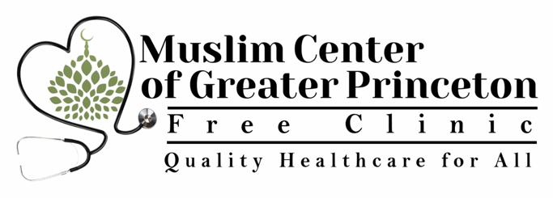
MCGP Free Clinic Volunteer Health Professional (VHP) Credentialing Form 1

Date of completion of form:

• Prefix:
• First Name:
• Middle Name:
• Last Name:
• Professional Designation (e.g., MD, RN, PA, etc.):
Current work title:

Contact Information

• Work Email Address:
• Work Phone Number:
• Work Fax Number:
• Work Mailing Address:
• Personal Email Address:
• Personal Phone Number:
• Personal Fax Number (if any):
• Personal Mailing Address:

• Role(s) in Health Center:
• Specialty:

How much time are you able to dedicate to the clinic? Select one.

___ Once a week
___ Twice a week
___ Three days a week
___ Other

If you are interested in giving lectures to the MCGP or interfaith community, please list topics below:

Educational and Training Background

Medical Education

School | Location | Date of completion | Degree obtained

Post-Doctoral Education (List all medical internships, residencies and fellowships):

Hospital | Location | Date of completion | Specialty

Medical Licensure (List all)

Specialty | State | License number | Expiration Date | Active?

Certifications

 | Specialty | Expiration Date | Active?
Board Certification
(List all)
BLS | N/A
ALS | N/A
PALS | N/A
Others:

List TWO Professional References:

Name | Title | Email Address or Phone Number

Medical Malpractice History

• Do you have any history of state board disciplinary actions and/or state or federal court (including any FTCA) malpractice claims within ten (10) years prior? Include both
pending and resolved administrative and
civil claims.
[ ] Yes [ ] No

If yes, provide a list of the claims or actions.

For each claim or action, include:
• Area of practice/specialty
• Date of occurrence
• Summary of allegations
• Status or outcome of claim or action

HEALTH CENTER VOLUNTEER HEALTH PROFESSIONAL FEDERAL TORT CLAIMS ACT (FTCA) PROGRAM
Sample Volunteer Agreement) between volunteer health professional(s) (VHP) and FTCA deemed health centers receiving funds under Section 330 of the Public Health Service (PHS) Act (42 U.S.C. 254b). This sample Volunteer Agreement is intended as non-binding guidance to assist health centers and health professional volunteers in developing an appropriate agreement regarding the volunteer’s provision of health services on behalf of the health center.
Volunteer Health Professional Agreement
This agreement is between _________________ (volunteer) and __________ (name & address of health center).
- The parties to this agreement understand that the volunteer named above is a volunteer of the named health center and is not an employee or contractor of the named health center.
- The parties to this agreement understand that the health center sponsor the named volunteer for the purpose of receiving deemed PHS employment status, with associated FTCA coverage.
- The parties to this agreement understand that the volunteer named above will not receive any compensation for services rendered, including reimbursement from any third party payor (including reimbursement under any insurance policy or health plan, or under any Federal or State health benefits program). The volunteer may receive repayment from the health center for reasonable expenses incurred in providing the service to the patient as agreed upon in the terms and conditions of this agreement.
- The parties of this agreement understand that before the service is provided, the volunteer or the health center will post a clear and conspicuous notice at the site where the service is provided of the extent to which legal liability of the volunteer is limited.
- The parties of this agreement understand that at the time services are rendered, the volunteer will be licensed or certified in accordance with applicable federal and state laws.
- The parties of this agreement understand the following to be the further terms and conditions of the services that the volunteer will provide on behalf of the named health center:

The health center may wish to seek legal advice regarding additional appropriate terms to include in the agreement [The health center and volunteer health professional may agree upon the exact terms and conditions of the relationship. The following are example provisions and not an exhaustive or mandatory list. ]
- Role/specialty

- Days/Hours
- Supervision
- Adherence to state licensure and credentialing and privileging requirements
- Documentation of participation in off-site events

Acknowledged:
_____________________________ (Volunteer Signature)
_____________________________ (Health Center Designee Signature)
_____________________________ Date

Last edited June 18th, 2019

