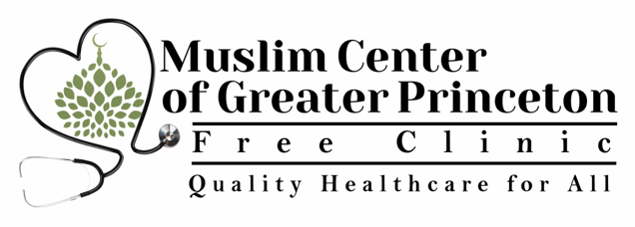
Special Needs Questionnaire for MCGP Saturday School Students

Student Name ______________________________ Date of Birth____________
Sex_____ Age_____

Emergency Contact Name ____________________________
Home Phone _____________ Cell_____________

Work___________ Best number to contact in case of emergency_______________

The MCGP Free Clinic is an FTCA covered entity. Under federal law relating to the operation of health centers, the Federal Tort Claims Act (FTCA) provides the exclusive remedy for damage from personal injury, including death, resulting from the performance of medical, surgical, dental, or related functions within the scope of deemed employment by any volunteer of a deemed health center who the Department of Health and Human Services has deemed to be an employee of the Public Health Service. (See Public Health Service Act subsection 224(q), codified at 42 U.S.C. § 233(q)
Pre-existing Medical Conditions
__________________________________________________________________________________________________________________________________________________________________________________________________________________________________________

Medications
____________________________________________________________________________________________________________________________________________________________

Please detail the medical attention your child requires (Medications/dosages/times/situations)
________________________________________________________________________________________________________________________________________________________________________________________________________________________________________________________________________________________________________________________

Please detail the extent by which your child can manage his/her medical needs
__________________________________________________________________________________________________________________________________________________________________________________________________________________________________________

Please list any allergies your child has and symptoms of their allergy
____________________________________________________________________________________________________________________________________________________________
______________________________________________________________________________

We recommend that you attach a picture of your child with this form.

The form and picture should be emailed to Dr. Hina Ghory (hghory@yahoo.com); it will then be placed in your child’s folder at the MCGP Free Clinic. Once we receive this form, we will contact you with any further questions, and waivers for medication administration, if needed.

Parent/Guardian Name__________________________________

Parent/Guardian Signature_________________________________ Date______________

